Excel Homework _ Daniel Kim

1. Given the provided data, what are three conclusions we can draw about Kickstarter campaigns?
   * 1st pivot shows that which parent catalog has most successful rate in crowdfunding service
   * Average number of successful projects are 273 on parent category, and average total projects number is 457. Average success rate is 59%.
   * Highest number of fund project category is ‘Theater’ 1,393 case (33%).
   * Highest success rate fund is ‘Music’ 77%.

|  |  |  |  |
| --- | --- | --- | --- |
| Parent Category  (Pivot 1) | Successful | Failed | Total |
| Mean | 273 | 191 | 457 |
| Median | 156 | 140 | 237 |

* + Based on 2nd pivot table, ‘Plays’ in theater category has the highest number of fund cases. Rock, Non-fiction, radio & podcasts, hardware, Documentary have 100% success rate of funding service
  + Music category has over 77% success rate. Excluding faith, jazz, and world music, ‘Music’ has over 96% success rate.

|  |  |  |  |
| --- | --- | --- | --- |
| Subcategory  (Pivot 2) | Successful | Failed | Total |
| Mean | 104 | 64 | 100 |
| Median | 60 | 44 | 60 |

* + Since Theater has extremely higher than other categories, median would be better reference for analyzing data. Based on data, approximately 60 projects ran on each subcategory.
  + Based on 3rd pivot table, May has highest number and rate of success fund service and December has lowest number and rate of success fund service. May to June will be best month for getting fund service. (average 223 success projects)

|  |  |  |  |
| --- | --- | --- | --- |
| Monthly Graph  (Pivot 3) | Successful | Failed | Total |
| Mean | 182 | 127 | 338 |
| Median | 183 | 127 | 335 |

* + Mean would be best reference for representing which month will represent best time for fund service.

1. What are some limitations of this dataset?
   * Data has extremely low and high value of fund amount, percent funded, and fund.
   * Only use sample data as 4,000 samples out of 300,000 projects / 40 Million dollars out of 2 Billion
   * Used data only available in Kickstarter.
2. What are some other possible tables and/or graphs that we could create?
   * Fund amount
   * Fund percent
   * How much money does project need for fulfill requirement of success of funds?

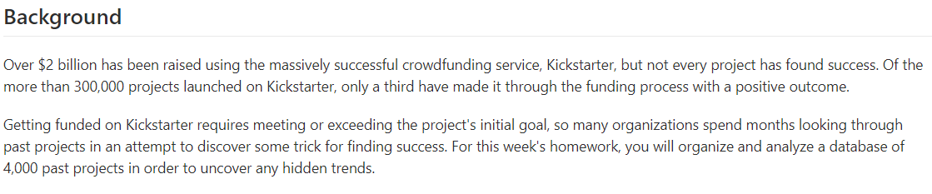

Bonus

* Use your data to determine whether the mean or the median summarizes the data more meaningfully.
  + Since data set has extreme high and low value, median will be more meaningful.
* Use your data to determine if there is more variability with successful or unsuccessful campaigns. Does this make sense? Why or why not?
  + Based on SD and IQR, data of successful case are more spread. Variability represent how spread out data is. If each data has similar value, it means that data has less variability, while data set that is spread out have higher variability.